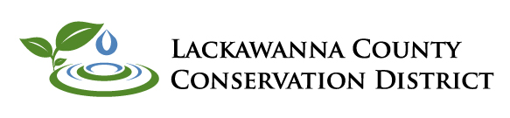
______________________________________________________________________________

Annual Report 2020
What is a Conservation District? What does a Conservation District Do?
The Lackawanna County Conservation District is a legal subdivision of state government, established by Lackawanna County Commissioners in 1958. The District is responsible for conservation work within the County's boundaries. These efforts are intended to improve the health of the soil, water & other natural resources.
The District is governed by a volunteer Board of Directors. Members of the Board are responsible for setting long term goals & objectives, as well as prioritizing District efforts. Conservation District staff have expertise in a diverse range of conservation topics such as: stream health, soil & water conservation, dirt & gravel/low volume road maintenance, environmental education, agricultural land preservation, nutrient management & agriculture best management practices.
Erosion and Sedimentation Pollution Control Program
Administration of the Chapter 102/NPDES Permit Programs continues to be one of the District's cornerstone programs. Required activities within this program are: Erosion & Sediment Pollution Control Plan (E&S) reviews, earth disturbance site inspections, (NPDES) National Pollution Discharge Elimination System permit processing, and complaint investigation.
PA Code title 25 Chapter 102 requires the development and implementation of an E&S plan for all earth disturbance activities in special protection watersheds and for earth disturbance activities of 5,000 sq ft or larger in non-special protection watersheds.
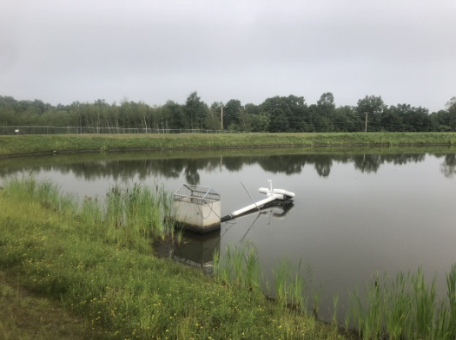
These regulations also require stormwater discharges during construction activities to be authorized under an NPDES permit. General NPDES permits can be authorized in non-special protection watersheds (Chapter 93 classification of (CWF-MF) cold water fishes-migratory fishes or lower) and by an Individual NPDES permits in special protection waters (high quality or exceptional value). Projects in Special Protection Watersheds have additional requirements to help protect and maintain the existing water quality.
During the 2020 calendar year 127 E&S plan reviews were conducted, 129 E&S inspections completed, information and/or technical assistance provided to 898 individuals through meetings and telephone conferences. In addition, 35 NPDES permits were reviewed. The total earth disturbance associated with new E&S plan reviews was 1,065 acres.

Chesapeake Bay & Agricultural Conservation Programs - Eric Johnson
2020 was a year of adaptation within the Conservation District and our agricultural programs. Despite the Covid-19 pandemic, we were still able to make progress towards our goals within the Chesapeake Bay Program and beyond.
We spent a significant portion of time completing farm inspections and providing technical assistance in all facets of agricultural production to our County farmers and landowners. The purpose of these farm inspections is to: 1) verify the existence of required manure management and erosion and sedimentation control plans, 2) identify any significant resource concerns on farms, and 3) promote the installation of agricultural best management practices (Ag BMP’s) and provide information on other District programs such as Farmland Preservation, No-till and the Lackawanna County Ag BMP Program. In 2020, 31 farm inspections were completed. While we fell short of our 50 inspection goal, we were glad to have connected with the landowners we were able to reach and help them towards full compliance!
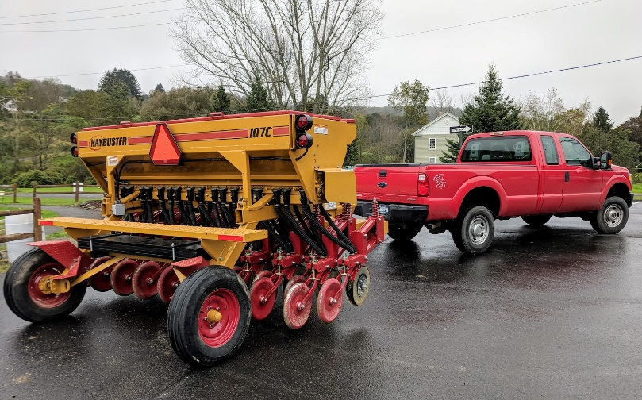
Our Soil Health and Equipment Rental Programs had a busy year. Our no-till drill, planted over 650 acres on 41 farms in Lackawanna and Wayne County! Part of that success was thanks to our Soil Health Enhancement Program. In 2020 (year 2), we provided reimbursement to 7 farms who planted 238.9 acres of cover crops. We also rented our bulk material spreader to 5 farms to spread lime and fertilizer in 2020.
Looking forward, we anticipate a very busy 2021 for our programs. In addition to a planned goal of 69 farm inspections, we have 2 projects planned through our Conservation District Ag BMP Program. We also will be spending a big chunk of time assisting with the development of a County-wide Action Plan to further the goals of the Chesapeake Bay Program here in Lackawanna County. Last, but not least, we are planning the rollout of a new program to provide further technical and financial assistance to our Lackawanna County farmers and landowners who want to establish new, or improve upon existing, stream/pond/wetland buffers. Stay tuned for more details, and we look forward to continuing to do our part to protect water quality here in Lackawanna County and in the Chesapeake Bay!
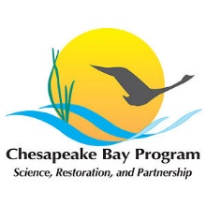
2020 Seedling Sale
With COVID-19 putting a halt to a lot of events, we felt we could keep the annual seedling sale going by delaying it a few weeks and having a drive-thru pick up to keep everyone safe. We continued to offer a variety of different plant species. This past year varieties included: apple and pear fruit trees, Norway Spruce trees, blueberry bushes, strawberry plants and perennial flowers that included Sundrop, Soapwort, Balloon Flower, Columbine & Blazing Star. This year we also offered deciduous azaleas as well as a Butterfly & Hummingbird Seed Mix. The money raised from the seedling sale funds our scholarship program for high school seniors.

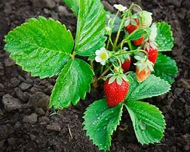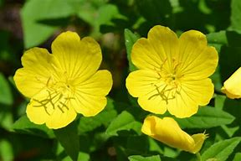

Dirt & Gravel Road/Low Volume Road Program
The goal of the Dirt & Gravel Road/Low Volume Road Program is to create a more environmentally & economically sustainable low volume network through education & project funding. The Lackawanna County Conservation District in partnership with local municipalities has undertaken many road improvement projects since the beginning of the program in 1998. The projects address the stabilization of road surfaces, drainage swales and road banks. The installation of cross pipes, drain tile and outlet protection are examples of practices eligible for funding under the program. The low volume road component was added to the program in 2015. In 2020, the District and its partner municipalities completed two Dirt & Gravel Road and one Low Volume Road projects in three different municipalities within Lackawanna County. Total value of all projects was $138,732.99. This figure includes both grant funds and in-kind contributions from the municipalities. Municipalities interested in qualifying for the D&G/LVR Program must have a representative attend special training. Additional information can be obtained by contacting the District.

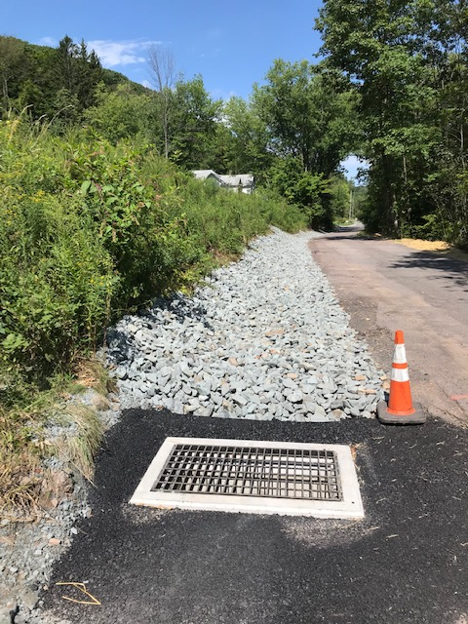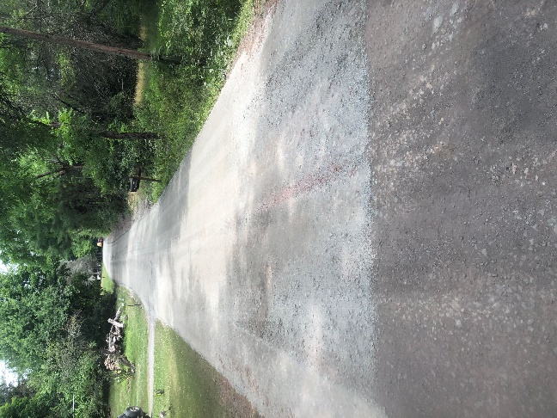

Farmland Preservation Program
2020 proved to be another busy year for the Farmland Preservation Program. The majority of the workload involved completing all the steps required to prepare farms from our 2019 application round for State Board approval and closing. In 2020, we preserved 2 tracts totaling 320.79 acres in Scott and Greenfield Townships. Funding for these purchases was provided through the Commonwealth and Lackawanna County. With these easements, we now have preserved a total of 5863.92 acres on 73 parcels in Lackawanna County since the program preserved its first farm in 1996!
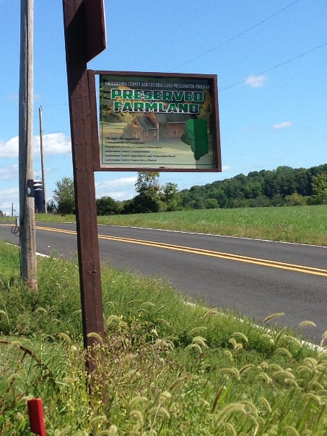
In addition, the District spent a large portion of time working with 2020 program applicants. We received 9 eligible applications for the 2020 program year. Funding was sufficient for us to accept 2 parcels into the program. Since then, a large block of time was been spent gathering the required forms and information, completing farm appraisals/surveys, and other steps in the process to purchase easements on those properties. We are working towards State board approval and closing for these farms in 2021.
The District continued to provide technical assistance and guidance to several interested landowners looking to apply for the program in 2021. Currently, we have a wait-list for the program, but we anticipate additional interest of new landowners for our 2021 funding round. Our application period closes on March 1st, 2021. In order to preserve additional acreage in 2021, we will be looking into a partnership with the Natural Resources Conservation Service’s Agricultural Conservation Easement Program (ACEP). Through ACEP, we can potentially get up to 50% matching funds to leverage our existing State and County easement purchase funds. This would go a long way to preserve more acres in Lackawanna County.
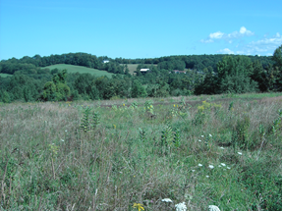
Last but not least, we spent time completing biennial easement inspections on our program farms. This included the inspection of 36 easements under the control of 31 different landowners. Due to the pandemic, these inspections were completed without landowner contact via “drive-by” inspections. While it didn’t allow for the normal opportunity to meet with all our landowners, we were still able to safely meet our program obligations and see how properties have changed or progressed over the years. We put great value on the relationships with our landowners and look forward to continued work with them in the future!
Given all of this, we consider 2020 a very successful year and look forward to making a big difference in protecting farmland for future generations in Lackawanna County in 2021 and beyond!

Watershed News
2020 Lackawanna County’s Virtual Envirothon
The Lackawanna Conservation District held a virtual competition in 2020 and will do so again in 2021. In 2020 Valley View and Abington Heights School Districts were the only schools competing. The District would like to recognize their willingness to participate under new and somewhat difficult circumstances.
EnviroDIY Mayfly Sensor Build and Installation
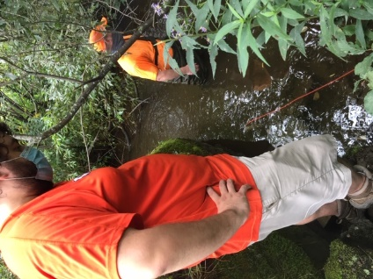
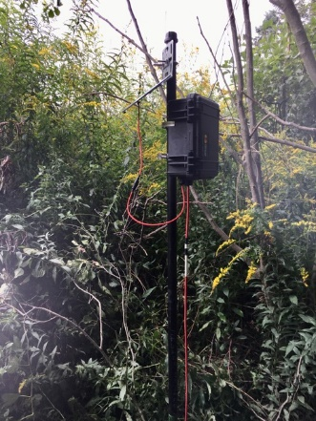
The Lackawanna County Conservation District partnered with EPCAMR to build and install a permanent solar-powered monitoring station that is monitoring and recording conductivity, temperature, and water depth every five minutes. The first unit was installed in the fall along the West Branch Lackawanna, providing us with valuable headwater data. The station will eventually include turbidity monitoring also, as soon as the newly designed sensor is available. We will be adding three more stations along the Lackawanna River. They will be co-located with the USGS flow stations so that we can take advantage of their flow data while analyzing data.
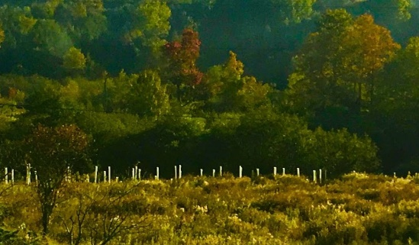
Chesapeake Bay Foundation’s Keystone 10 Million Tree Initiative Partner
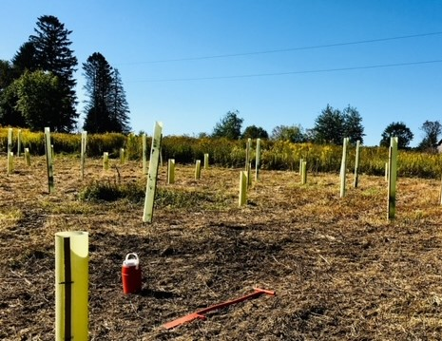
LCCD became a partner in the Keystone 10 Million Tree Initiative. The Partnership aims to facilitate the planting of 10 million new trees in priority landscapes in Pennsylvania by the end of 2025 through partnerships that helps to promote, preserve, and protect streamside buffers to improve water quality in PA. The Initiative Partnership provides tree and shrub seedlings, shelters, and stakes to be planted along streambank and upland locations in the Bay watershed. The District provided over 300 trees and shrubs in 2020 to both Trout Unlimited and the Lackawanna River Conservation Corps to be planted along Leggetts Creek and the Lackawanna River.
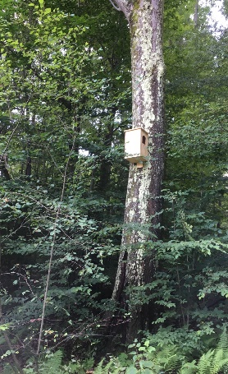
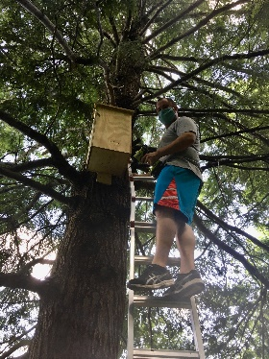
PA Game Commission Wildlife Boxes (cont.)
The District has continued installing wildlife boxes purchased from and built by the PA Game Commission and installed in Lackawanna County Parks. These boxes were purchased through the Districts W.I.P. (Watershed Improvement Program) which is funded through Act 13 funds. We will continue to install additional boxes at the Lackawanna State Park once the warmer weather arrives.

Urban Wildlife Kit
The District received an Urban Wildlife kit from the PA Game Commission for use in Wildlife Education Programs. The kits consist of 12 pelts, 12 information sheets, 8 information cards, 4 books, 8 scat replicas, and 8 track replicas. These kits are available for wildlife educational programs presented by the District and other organizations to sign out.
Chesapeake Bay Regional Engineering Assistant

The Lackawanna County Conservation District hosts a Regional Chesapeake Bay Engineering Assistant position covering a seven-county area in Northeastern Pennsylvania within the Chesapeake Bay Watershed. The position is responsible for the design & inspection of Agricultural Best Management practices intended to minimize sediment & nutrient pollution within the Bay Watershed. Below is a brief synopsis of the projects completed in 2020.

City of Scranton – Two Emergency Watershed Protection Projects Totaling 402’of Streambank Restoration

Susquehanna County – 9 Emergency Watershed Protection Projects throughout the County.
Guy Parrish Farm – Installed a heavy use area to contain animals and nutrients from leaving the site.
Aldrich Farms – Installed watering system to keep animals out of the creek.

LACKAWANNA COUNTY CONSERVATION DISTRICT
1038 Montdale Road, Room 109
Scott Twp, PA 18447
PHONE: 570-382-3086
FAX: 570-382-3485

DISTRICT DIRECTORS
Commissioner – Chris Chermak
Chairman - Jay Clymer
Vice-Chairman - Thomas Milewski
Treasurer - George Sheypuk
Farm Director - Lewis Peregrim
Urban Director - Frank Kozik
Urban Director - Ronald Phelps

ASSOCIATE DIRECTORS
Edward Sokoloski
John Howanitz
Charles Charlesworth
Alana Roberts

DISTRICT STAFF
District Manager - Jerry Stiles
Administrative Assistant - Lois Sherman
Erosion & Sedimentation Control Technician - Tim Matechak
Erosion & Sedimentation Inspector - Kim Nagle
Chesapeake Bay Technician/Farmland Preservation - Eric Johnson
Chesapeake Bay Engineering Assistant - Bill Zavislak
Watershed Specialist - Cheryl Nolan

