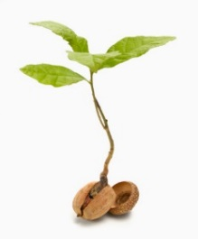
2018 Seedling Sale
Seedling | Size | Price Per Unit | # of Units | Total $
Apple Trees | 4’ - 5’ Whips | $23.00 for Two Trees
Peach Trees | 4’ – 5’ Whips | $23.00 for Two Trees
Plum Trees | 4’ – 5’ Whips | $25.00 for Two Trees
Paw Paw Trees | 6”-12” Seedlings | $7.00 for Two Trees
Blueberry Bushes | 12”–18” Potted Plants | $20.00 for Two Plants
Strawberry Plants | Root Plugs | $7.00 per bundle of 25
Eastern White Pine | 12” – 20” Transplants | $8.00 for bundle of 5
Golden Raintree | 2” - 4” Seedlings | $5.00 for bundle of 5
Beardtongue | Potted Plants | $10.00 for 4 plants
Coreopsis - Tickseed | Potted plants | $10.00 for 4 plants
Beebalm | Potted Plants | $10.00 for 4 plants
Rhododendron  Color choices:  Red, White, Pink or Purple | 6” – 18”  Potted plants | $10.00 for each pot | ____Pink  ____Purple  ____Red  ____White
*Orders must be received by April 6, 2018* |  |  |  | Total:
** Mail this form with order and check made payable to: **
Lackawanna County Conservation District (LCCD)
1038 Montdale Road, Room 109
Scott Township, PA 18447
(570) 382-3086
Name:________________________________________________Date:____________
Address:____________________________________________________
City:________________________________ State:_______ Zip:_________
Phone:_______________________ Email:___________________________________
- - - - - - - - - - - - - - - - - - - - - - Detach here to keep as a Reminder - - - - - - - - - - - - - - - - - - - -
The District is not responsible for orders not picked up.
Plants are not guaranteed to survive when planted.
Pickup Dates: Friday April 20th (9am-4pm) & Saturday April 21st (9am-11am)
Pick up at District Office: 1038 Montdale Road - Room 109, Scott Township
Apple Trees (Malus domestica)  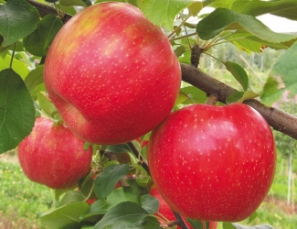 | An order consists of one “Honeycrisp” and one “Enterprise” Apple tree. The trees are bare root whips which are approximately 4’ to 5’ tall. Both varieties are well suited to the back yard grower. Honeycrisp is a crisp, juicy, sweet-tart apple. Enterprise is a late-maturing, deep red apple with good keeping qualities and is highly resistant to fire blight and cedar apple rust. Both are EMLA 7 rootstocks.
Peach Trees (Prunus persica)  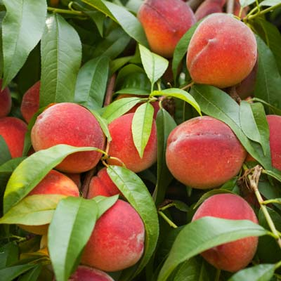 | An order consists of one “Cresthaven” and one “Contender” Peach tree. Trees produce delicious fruits within a few years. Both are very firm with excellent color. Cresthaven is winter hardy, very productive and has medium vigor. Extra fertilization is recommended to maintain tree longevity and vigor. Contender is high-quality, freestone variety that is hardy and very productive.
Plum Trees (Prunus)  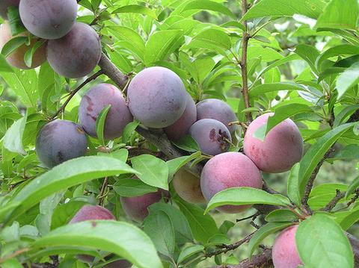 | An order consists of one “Ruby Queen” and one “Methley” Plum tree. These plum trees are of the Japanese variety. Ruby Queen has outstanding flavor with reddish-black skin and a firm red flesh. Methley is an early plum with fine quality and appearance. The fruit is purple with red, sweet flesh and very juicy with a distinctive flavor. Sold in pairs for adequate cross pollination.
Paw Paw (Asimina triloba)  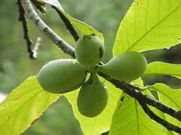 | An order consists of 2, 1 year seedlings, 6-12 inches. A deciduous, often narrow conical tree growing 12-25 feet tall with dark green leaves that can grow up to 12” in length. The Paw Paw fruit is an oblong shaped fruit, light green in color, weighing 5-16 ounces and 3-6 inches in length. The inside has a creamy, custard texture varying in color from creamy-white to yellow-orange. The taste is described as a cross between a mango and a banana. Plant at least 2 trees for fruit production to ensure cross pollination.
Blueberry Bushes (Vaccinium)  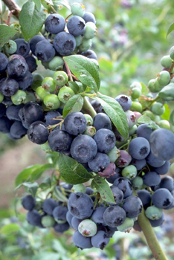 | An order consists of one “Spartan” (Early-Mid) and one “Blue crop” (Mid) blueberry bush obtained from a local berry farm. Plants are of bearing age and with care, will develop large flavorful berries. Select a sunny, well-drained site with sandy or loamy soil. You may need to add soil amendments. Sold in pairs to provide cross-species pollination.
Strawberry Plants (Fragaria)  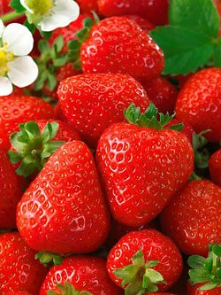 | An order consists of 25 strawberry vine plugs. The flavorful variety is “Seascape” a productive day-neutral variety. Highly successful for Northeastern growers for summer and fall production. Seascape will flower and fruit all season. The berries are large, prolific, and have good flavor when picked ripe.
Eastern White Pine (Pinus strobus)  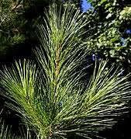 | An order consists of 5, 4 year old transplants ranging in height from 12-20 inches. Fast growing 50-80 feet. Spread 25-40 feet. A five needled pine, with soft, blue-green needles. Can tolerate dry, rocky soil. Grows in normal moisture conditions but can tolerate wet, swampy areas. Ideal for specimen planting, shade, windbreaks and appealing Christmas Trees. Can be easily restrained to manageable height by pruning. For screen or Christmas trees, shear when new growth appears. It is easily controlled and is good for small properties as well as field plantings. A majestic evergreen.
Golden Raintree (Koelreuteria paniculata)  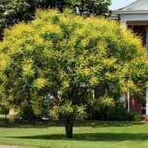 | An order consists of 5, 1 year seedlings ranging in height from 2-4 inches. A small, deciduous, open branching, flowering ornamental shade tree that grows to a height of 30’– 40’ tall. Spread 30’-35’. The pinnate leaves emerge pinkish bronze to purplish in spring, mature to a deep blue-green in summer and turn yellow in the fall. In early spring, showy 4-petaled yellow flowers appear in airy panicles 12 to 15 inches long. Some say the falling blossoms resemble ‘Golden Rain’. The flowers give way in late summer to interesting, deep rich orange 3-sided air filled capsules that look like golden-orange paper lanterns and contain hard, black seeds. Choose a sunny spot to plant. Attracts bees. Disease and pest resistant. Can tolerate heat, harsh climates and air pollution stress. Grows in a wide variety of soil types including acidic, alkaline, sandy, loamy, wet and clay soils that are well drained. Attractive shade tree for small spaces. Known for its neat habit and well behaved root system. A very effective landscape focal point, street tree and ideal for parkway
Beebalm (Monarda)  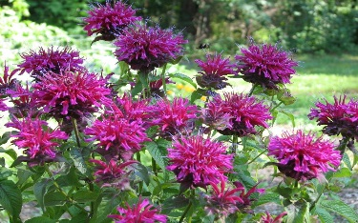 | An order consists of 4 potted seedling plants. The plant blooms from early to late summer and grows 2 to 4 feet tall, depending on the variety. Butterflies, hummingbirds, bees, and other nectar-seeking creatures covet the tubular flowers on the plant's rounded flower heads. Bee balm flowers are brilliant additions to your garden!
Beardtongue (Penstemon)  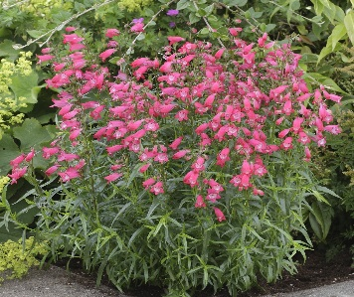 | An order consists of 4 potted seedling plants. Beardtongue flower plants are herbaceous perennials that feature lance shaped foliage and spikes of tubular flowers. They are a valuable source of nectar for hummingbirds, bees and butterflies. Deer avoid them. Plants typically bloom in early summer and range in height from 1-3 feet tall. The nickname of bearded tongue refers to the pollen-free stamen that protrudes from the flower, resembling a bearded iris in this aspect.
Tickseed (Coreopsis) 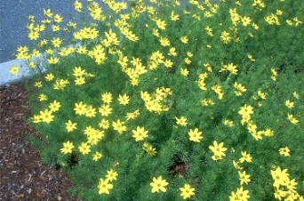 | An order consists of 4 potted seedling plants. Coreopsis plants, commonly known as Tickseed, attract butterflies and are deer resistant. Prized for its long bloom period, our native Coreopsis are renowned for their cheerful yellow flowers. From late spring to late summer, you can count on the welcoming yellow blooms of Tickseed. Coreopsis are easily grown and make good cut flowers. These perennial plants prefer well-drained soil in full sun. Remember to keep the plants deadheaded for best flowering. Make sure to leave a few seed heads at the end of the season so the plant will reseed itself.
Rhododendron (Rhododendron)  Color choices:  Red, White, Pink or Purple | An order consists of one large leaf Rhododendron plant. Size, depending on variety, can range from 6”-18” in a one gallon pot. You pick your color choice. Will bloom late May to early June. Leaves are large, dark green year round. Grown at a local farm.
Lackawanna Conservation District
1038 Montdale Road, Room 109
Scott Township, PA 18447

